Wk 8

Index fossils—really?

Index, noun; a pointer, indicator, a thing that points out. (Webster’s Dictionary)
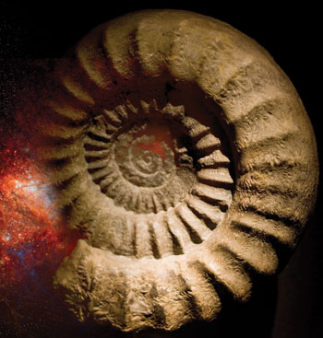©iStockPhoto.com/antb
by Gordon Howard
Evolutionary paleontologists use ‘index fossils’ to assign an age to a layer of sedimentary rock and its associated fossils.
Evolutionary theory assumes that a particular creature evolved from its ancestors, lived successfully for a period, then became extinct as its descendants evolved better ways of surviving. In other words, that creature had a defined ‘evolutionary life-span’. We may be told, “It thrived in the Devonian period”. For example, we all ‘know’ that the dinosaurs ‘evolved’ about 230 million years ago, and died out 65 million years ago, don’t we?
Or do we? To ‘know’ that, people need to make two assumptions.

Assumptions
One is that fossils and rocks can be accurately assigned an ‘age’ directly, through various scientific techniques. However, no matter how accurate the measurements of chemicals in the rocks are, there is no way of calibrating a dating technique for supposedly pre-historic events.¹ In spite of paleontologists trying to make sense of these scientific measures, the ‘dates’ they assign to rocks are actually constrained by the fossils found in them.
But can we be sure that, if a creature does not appear in the fossil record of a particular age range of rocks, it did not exist then? No, we can’t.
For example, if dinosaur fossils are found in a rock layer, the rocks are assumed to be at least 65 million years old. So if a radiometric dating result indicates an age of 40 million years, it is interpreted as representing, not the age of the rock, but a later geological process, such as disturbance, reworking or contamination. The fossils always trump the supposedly objective radiometric dating!²
The second assumption has two complementary parts. First, in the strata above and below (“after and before”) the range where fossils of a particular creature are known, it is assumed it didn’t exist at that time. Evolutionists would say either that it hadn’t evolved yet, or that it had become extinct. Second and conversely, if a particular fossil is frequently found in rocks of a particular ‘age’ then we can say that that creature is an indicator fossil for rocks of that age—an ‘index fossil’. In other words, rocks that contain fossils of that creature must be of that ‘age’, and so must any associated fossils.
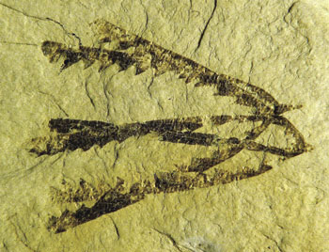Graptolites, fossils of colonial marine creatures, are widely used as index fossils.
But can we be sure that, if a creature does not appear in the fossil record of a particular age range of rocks, it did not exist then? No, we can’t.
Consider the many so-called ‘living fossils’—creatures whose fossils are not found in any rocks younger than a certain age, but discovered alive today. One famous example is the coelacanth, a fish regarded as becoming extinct supposedly 65 million years ago because it was missing from the fossil record since then. Yet, in 1938, it was discovered to be still alive. Similarly, the recent discoveries in the last two decades of dinosaur bones that contained tissue that was still flexible, as well as blood cells, challenges the idea that dinosaurs disappeared from the earth 65 million years ago.³
These examples show the futility of this assumption. The fact that an organism is not found in the fossil record does not mean it was not alive somewhere on the earth. For example, ‘ancient’ and ‘primitive’ organisms (crinoids, mosses, stromatolites, etc.) have flourished from very early in the fossil record and continue in our present world, but they don’t appear in all levels of the geologic column. Evolutionists themselves recognize this with their adage, “Absence of evidence is not evidence of absence.” But it’s certainly no evidence of presence!

Ranges keep growing

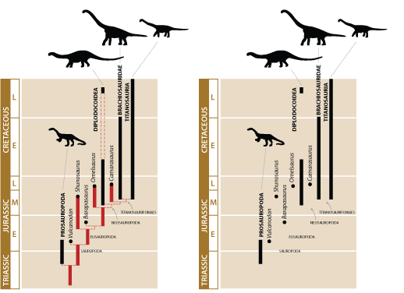
Left: Part of the dinosaur ‘evolutionary tree’ (the sauropods).⁸
Right: The ‘tree’ disappears when areas are removed for which there is no fossil evidence
This should alert us to the fact that we cannot assume that the dates assigned to an ‘index fossil’ are real limits on its period of existence. ‘Out-of-place’ (or ‘offset’) fossils are not uncommon,⁴ such as fossil fish being found in China millions of years older than previously thought.⁵ Such discoveries are not reported to be ‘out of place’ but are catered for by increasing the fossil range of the organism. Consequently, the ‘evolutionary life-span’ allotted by evolutionists for many index fossils has continually been increasing, as examples are found in rocks of different assigned ‘ages’.⁶
Another factor that challenges the million-year ages produced by these dating methods is the absence of evolutionary change in many organisms over these vast periods, a phenomenon that is even given a name—stasis. How is it that crinoids and the coelacanth have not evolved in those millions of years? Change would show the passage of time. Lack of change throws doubt on the idea of millions of years and that evolution happens at all.
Lack of change throws doubt on the idea of millions of years and that evolution happens at all.
When they are interpreting the fossils, evolutionary geologists assume that animals evolved over millions of years, and that fossils buried together, (that is, in the same layer of rock) lived together at the same time. They assume that layers in different parts of the world containing the same fossils are the same age. This is the whole idea behind using index fossils to relate rocks around the world. But suppose there was a world-wide flood. Then the vast majority of fossils would all have been buried during that Flood year. Different layers would contain fossils transported from different ecosystems rather than different evolutionary time periods, completely destroying the idea that index fossils represent different evolutionary ‘ages’. With the global Flood we would expect particular fossils to sometimes be present and sometimes absent from layers of the same ‘age’ in different parts of the world, as well as ‘index fossils’ to be found in rocks of supposedly ‘wrong’ age.
©iStockphoto.com/hsvrs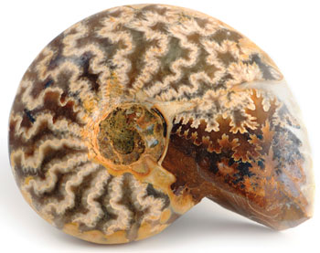Ammonites, picture an octopus with a shell, are well known as index fossils
A typical diagram of an ‘evolutionary tree’ has the creature assigned to an ‘evolutionary life-span’ (see above). The vertical line shows the point at which it ‘appears’, and continues, either to the present, or to a point where it stops abruptly, indicating the point where evolutionists believe the creature became extinct. But, as we have seen, it may not be extinct but still alive somewhere on the earth today. It’s just missing from parts of the fossil record. More importantly, it’s possible that the creature existed before it first appeared as a fossil. In fact, its ‘kind’ was alive on the earth from creation up to its first ‘appearance’ as a fossil. It would then ‘appear’ in the fossil record fully formed, without ‘evolutionary ancestors’, just as the Bible predicts, and just as we actually find in the rocks.⁷

No such thing
What can we deduce from all this? Basically, that index fossils are no such thing. They are not indicators of an evolutionary progression, and they cannot be relied on without question as indicators of the age of any particular rock layer. If they ‘indicate’ anything at all, it is that God created the different kinds of animals and plants fully formed, and buried them in His judgment on the world in the biblical Flood about 4,500 years ago.

Living fossils: a powerful argument for creation

Don Batten interviews Dr Carl Werner, author of Living Fossils (Evolution: the Grand Experiment vol. 2)
Dr Werner
Dr Werner graduated from the University of Missouri with distinction in biology (summa cum laude). He received his doctoral degree in medicine at the age of 23 and practices emergency medicine in St Louis.
Dr Werner explained what living fossils are and why he became so interested in them, collecting photographs of these fossils over the last 14 years: “Living fossils are fossilized animals and plants that look similar to modern organisms. I became interested in living fossils as a tool to test evolution.”
“There are basically two models of how life came about: The evolution model suggests that chemicals coalesced and formed a living single-cell almost four billion years ago and then this changed over long periods of time into all other living things. Examples of evolutionary changes include a dinosaur into a bird, or a four-legged land mammal into a whale. The other model, creation, suggests that an external supernatural being (God) created all of the various types of animals and plants at once, and these organisms have changed little over time, other than variations within a basic type.”
Dr Werner’s use of ‘type’ is similar to the biblical use of the word ‘kind’ in Genesis. For example, an animal can change, but only within its kind, such as a wolf into a dog—not radical change such as a four-legged mammal into a whale.¹
Dr Werner continued, “Living fossils provided me a simple way to test evolution. If evolution did not occur (animals did not change significantly over time) and if all of the animals and plants were created at one time and lived together (humans, dinosaurs, oak trees, roses, cats, wolves, etc), then one should be able to find fossils of at least some modern animals and modern plants alongside dinosaurs in the rock layers. I set out to test this idea without any foreknowledge of any modern organisms in the rock layers. My results (as laid out in the book & video Living Fossils) showed that many modern animals and plants are found with dinosaurs—far more than I ever expected to find.”
Contrary to popular belief, modern types of birds have been found [in ‘dinosaur rock’] including: parrots, owls, penguins, ducks, loons, albatross, cormorants, sandpipers, avocets, etc.
Dr Werner and his wife Debbie travelled over 100,000 miles (160,000 km) and took 60,000 photographs as they filmed the television series Evolution: The Grand Experiment. (Episode 2 of this series, Living Fossils, reveals exactly what they found.) They focused on fossils found in dinosaur rock layers, and compared these fossils to modern animals and plants.
“We looked only at fossils found in the dinosaur dig sites so that scientists who support evolution could not suggest that the fossils we looked at were not ‘old’. All of the fossils we used for comparisons were found in dinosaur rock layers (Triassic, Jurassic and Cretaceous).”

Many modern animals in dinosaur rock!
I asked Carl just how many modern types of animals he had found in the dinosaur rock layers.
“We found fossilized examples from every major invertebrate animal phylum living today including: arthropods (insects, crustaceans etc.), shellfish, echinoderms (starfish, crinoids, brittle stars, etc.), corals, sponges, and segmented worms (earthworms, marine worms).
“The vertebrates—animals with backbones such as fish, amphibians, reptiles, birds and mammals—show this same pattern.”

Modern fish, amphibians and reptiles
“Cartilaginous fish (sharks and rays), boney fish (such as sturgeon, paddlefish, salmon, herring, flounder and bowfin) and jawless fish (hagfish and lamprey) have been found in the dinosaur layers and they look the same as modern forms.
“Modern-looking frogs and salamanders have been found in dinosaur dig sites.
“All of today’s reptile groups have been found in the dinosaur layers and they look the same or similar to modern forms: Snakes (boa constrictor), lizards (ground lizards and gliding lizards), turtles (box turtles, soft-shelled turtles), and crocodilians (alligators, crocodiles and gavials).”

Modern birds
“Contrary to popular belief, modern types of birds have been found, including: parrots, owls, penguins, ducks, loons, albatross, cormorants, sandpipers, avocets, etc. When scientists who support evolution disclosed this information during our TV interviews it appears that they could hardly believe what they were saying on camera.”
Dr William Clemens, UC Berkeley, on modern birds being found in Cretaceous rock. (Clip from Living Fossils DVD)
Paleontologists have found 432 mammal species in the dinosaur layers; almost as many as the number of dinosaur species. … But where are these fossils? We visited 60 museums but did not see a single complete mammal skeleton from the dinosaur layers displayed at any of these museums. This is amazing.

Mammals
“At the dinosaur dig sites, scientists have found many unusual extinct mammal forms such as the multituberculates² but they have also found fossilized mammals that look like squirrels, possums, Tasmanian devils, hedgehogs, shrews, beavers, primates, and duck-billed platypus. I don’t know how close these mammals are to the modern forms because I was not able to see most of these, even after going to so many museums.”
“Few are aware of the great number of mammal species found with dinosaurs. Paleontologists have found 432 mammal species in the dinosaur layers;³ almost as many as the number of dinosaur species. These include nearly 100 complete mammal skeletons. But where are these fossils? We visited 60 museums but did not see a single complete mammal skeleton from the dinosaur layers displayed at any of these museums. This is amazing. Also, we saw only a few dozen incomplete skeletons/single bones of the 432 mammal species found so far. Why don’t the museums display these mammal fossils and also the bird fossils?”

Many modern plants in dinosaur rock!
“In the dinosaur rock layers, we found fossils from every major plant division living today including: flowering plants, ginkgos, cone trees, moss, vascular mosses, cycads, and ferns. Again, if you look at these fossils and compare them to modern forms, you will quickly conclude that the plants have not changed. Fossil sequoias, magnolias, dogwoods, poplars and redwoods, lily pads, cycads, ferns, horsetails etc. have been found at the dinosaur digs.”
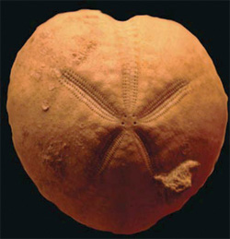
Fossil sea urchin
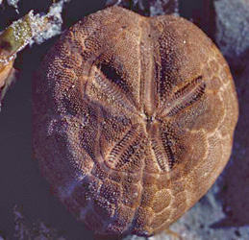
Modern sea urchin

Were any modern organisms not found?
“I did not find fossils of every organism living today in the dinosaur layers, rather I found representative examples from all of the major animal phyla living today and all of the major plant divisions living today. Taking it one step further, within these bigger groups, I frequently found representatives of all of the major groups or classes within a phylum. For example, for echinoderms (starfish, sea urchins, etc.) I found fossils of all of the major types living today. Same with the insects and the crocodilians, etc. I did not find any large mammals. The largest mammal discovered in a dinosaur layer so far (live size) is 30 pounds (13 kg). Nevertheless, with so many living fossils, both plants and animals, from all of the major phyla and all of the major plant divisions, it points to stasis (lack of change), not evolution. I should also note that if you look at the serious problems with the fossil layer system (the geological column as presented by geologists today), the absence of the bigger mammals can easily be accounted for, but I will save this for a later day.”

Evolutionary story telling ‘unsinkable’?
I asked Dr Werner how evolutionary scientists deal with this evidence, given these remarkable findings. Dr Werner remarked, “If you whole-heartedly believe in a theory, you will always be able to sustain that belief—even in the face of contradictory evidence—by adding a rescue hypothesis to that theory. For example, if a scientist believes in evolution and sees fossils that look like modern organisms at the dinosaur digs, he/she might invent an hypothesis to ‘explain’ living fossils this way: ‘Yes I believe that animals have changed greatly over time (evolution), but some animals and plants were so well adapted to the environment that they did not need to change. So I am not bothered at all by living fossils.’ This added hypothesis says that some animals did not evolve. But if a theory can be so flexible, adding hypotheses that predict the opposite of your main theory, one could never disprove the theory. The theory then becomes unsinkable, and an unsinkable theory is not science.”

Different names for the same animal?
Carl related how evolutionary scientists give fossils different genus and species names from the living forms, creating the illusion of evolution: “Let me give you an example. A scientist found a fossil sea urchin in Cretaceous rock that looks nearly identical to a modern Purple Heart sea urchin, but assigned it to a completely new genus (Holaster). If you saw that creature alive in the ocean you would recognize it as a Purple Heart sea urchin (genus Spatangus). The different name suggests that sea urchins have changed over time, but this is contrived ‘evidence’ for evolution. The fossil looks the same as the living one.” (See photos right).

Evolution disproved?
I asked Dr Werner if his study disproved evolution.
“It is becoming more and more difficult for the evolutionary model to stand in the face of this great number of living fossils. Adding the many other problems with evolution (fossil record, origin of first life, geological layering problems, similarities of non-related animals, etc.), you can declare with confidence that yes, the theory is finished. If a few larger mammals were found in the dinosaur layers, it should be over even for the die-hard believers of evolution, but people tend to go to their grave with the theories they learned in college. A new generation might well look at all of this and ask, ‘What were they thinking?’ ”

Are there out-of-sequence fossils that are problematic for evolution?
by Gary Bates and Lita Sanders
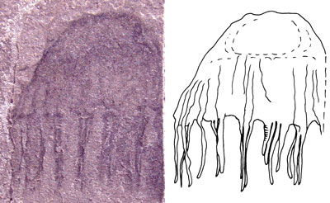This jellyfish fossil, which ‘dates’ to over 500 million years, provides two counts against evolutionary predictions regarding the fossil record: that soft organisms would not be preserved and that such a huge period of evolution sees no change in this creature, which has the same features as ones swimming in the oceans today. Image from PLOS, ref. 1.
In his debate with Ken Ham, Bill Nye (the ‘science guy’) dogmatically claimed, and asked Ham, to cite any out-of-order fossils in the geologic record, because if there were any, it would be problematic for the evolutionary model. Due to the seeming confidence of Nye’s assertion (and that it was not answered during the debate), many have contacted us for an answer on this single question. In addition, while out on ministry our speakers have mentioned how this question has often come up. At a recent event, Gary Bates encountered a Christian university student who said this question was being used as a club by lecturers and professors to ‘beat him with’. It appears that this seeming ‘knockout punch’ argument by Nye is being used as a ‘great’ falsification of the creation model.

A constantly changing story
If the fossils themselves provide evidence that suggests rapid burial then it only makes sense to presume that the sediments that buried them had to also be deposited quickly.
So how can we answer this challenge? Is this a problem for creationists? First, by definition evolutionists would say there are no out-of-sequence fossils. They would claim that the fragmentary nature of the fossil record means that we don’t have a good idea of the entire period a fossil belongs in. So if we find a fossil in a stratum that is supposed to be 100 million years older than the species (using evolutionary dating for the sake of the argument), it simply means that it evolved 100 million years earlier than we thought. The evolutionary interpretation of the fossil record is so flexible that it can incorporate virtually any new change, no matter how unexpected. In other words, if an out-of-order fossil is found (according to their standard view), then it is just incorporated as new evidence to provide a better understanding of evolution! In short, evolution is assumed and then used to explain the fossils. So, no matter what we find, by the very nature of the way they interpret the facts, nothing would falsify evolution anyway!
Fossil photo and diagram from D. Fuchs, G. Bracchi and R. Weis, ref. 2.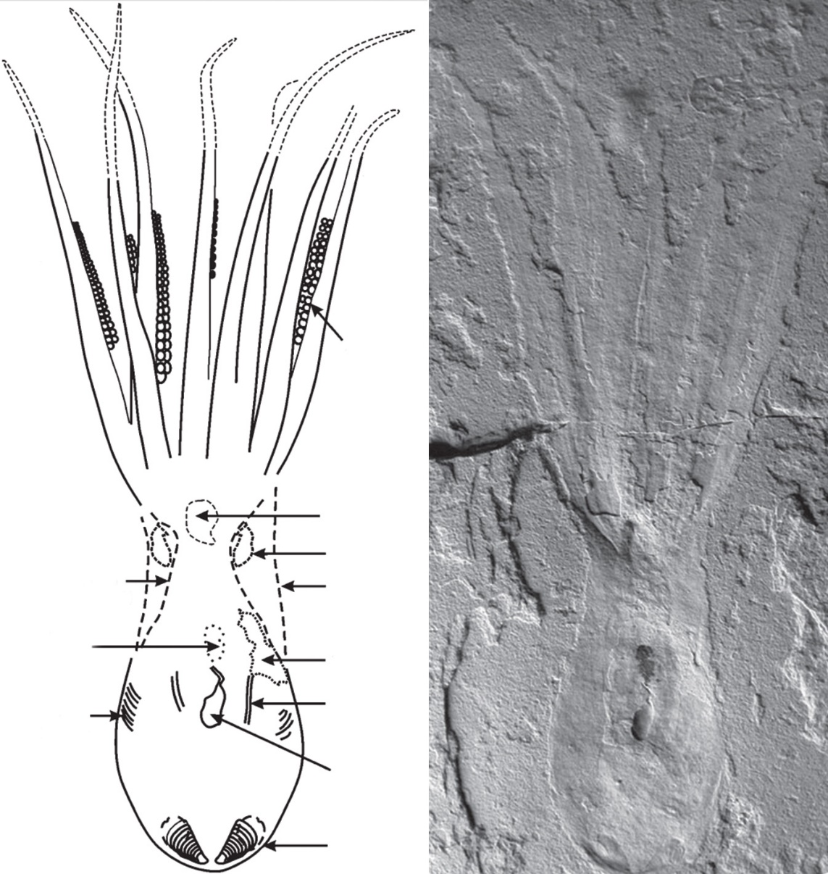Fossil octopus remarkably preserved in Lebanon reveals details of the eight arms, suckers, ink, gills, mouth, eye capsule and more.
So a better way to counter this would be to ask whether evolution has made predictions about the fossil record that have been confirmed or otherwise by subsequent discoveries. And by this measure evolution falls dramatically short. For instance, Charles Darwin said that “no organism wholly soft can be preserved.” He was simply wrong, because we have many examples of this. For instance, hundreds of fossilized jellyfish and a fossilized squid, that look remarkably similar to the same creatures living today. Yet they were claimed to be 505 million years old (myo) and 150 myo respectively. The squid even contained an ink sac so fresh that the ink could be used to paint a picture. The ages assigned to these fossils comes from their position in the alleged geologic column and the dates assigned to the rock layers in which they were found. Remember that it is believed that the rock layers were supposed to have been slowly deposited over millions of years, and similarly, the process of burial and permineralization is supposed to have taken a very long time. But besides soft-bodied creatures, we have fossils like an ichthyosaur giving birth, and fish in the process of eating other fish, that capture moments in time. They must have been preserved quickly. Logically, if the fossils themselves provide evidence that suggests rapid burial then it only makes sense to presume that the sediments that buried them had to also be deposited quickly.
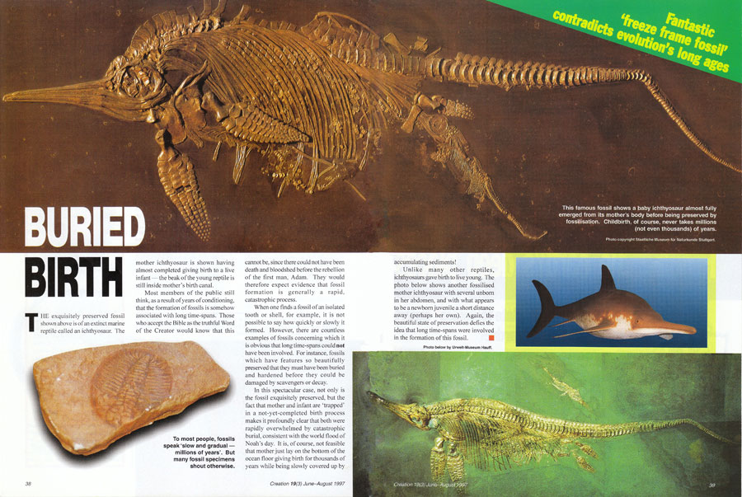

Lots of inconvenient fossils
In reality, there are a lot of fossils that don’t fit within the neatly-defined evolutionary order of things paraded in our geology and biology textbooks:
- Trilobites, which are allegedly 500 myo in the Cambrian strata, have eyes that are far too complex for their place in the fossil record. That is, they have no precursors to their appearance.
- Perhaps most astonishingly, pollen fossils—evidence of flowering plants—were found in the Precambrian strata. According to evolutionists, flowering plants first evolved 160 mya, but the Precambrian strata is older than 550 mya.
- Dinosaurs are supposed to have evolved into birds. But Confuciusornis was a true beaked bird that pre-dates the ‘feathered’ dinosaurs that it allegedly came from. It also has been found in the stomach of a dinosaur.
- Grass which has been found in fossilized dinosaur coprolites (fossilized dung). But grass is not supposed to have evolved until at least 10 million years after the dinosaurs went extinct.
- A dog-like mammal fossil was found with remains of dinosaurs in its stomach—but no mammals large enough to prey on dinosaurs were supposed to exist alongside them.
Photo by Linda Lou Haywood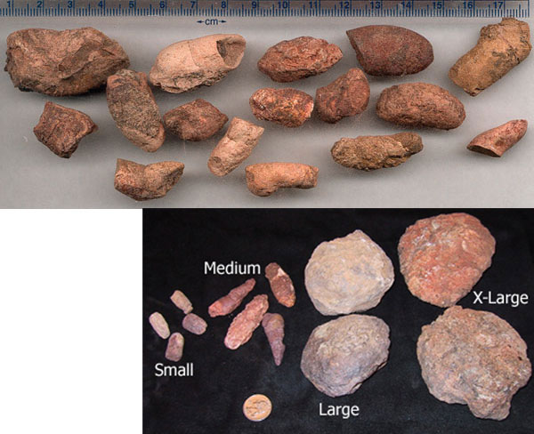
CMI’s Calvin Smith wrote:
“To the surprise of many, ducks,³ squirrels,⁴ platypus,⁵ beaver-like⁶ and badger-like⁷ creatures have all been found in ‘dinosaur-era’ rock layers along with bees, cockroaches, frogs and pine trees. Most people don’t picture a T. rex walking along with a duck flying overhead, but that’s what the so-called ‘dino-era’ fossils would prove!”

Tiktaalik! ‘You gotta be kidding’
© Ted Daeschler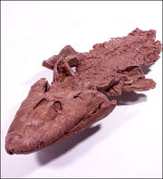Tiktaalik fossil.
Being the media entertainer he is, Nye waxed eloquently about the discovery of an alleged sea-to-land (fish to tetrapod) intermediate called Tiktaalik roseae. That he spent so long detailing the find of this ‘perfect missing link’, he obviously thought it was a ‘slam dunk’ for evolution. Indeed, Tiktaalik has appeared on the cover of numerous magazines, textbooks, and it even has its own theme song and website to promote evolution. Now, either Nye was ignorant of, or deliberately dishonest, when he conveniently failed to mention that fossil footprints that predated Tiktaalik have been in Poland predating Tiktaalik by some 18 million years. It can’t be the transition it is claimed to be if creatures that evolved ‘from it’ actually lived ‘before it’. That looks like a slam dunk for falsifying that evolutionary story, ‘wethinks’.

‘Living fossils’ are out-of-place for evolutionists
Piotr Szrek, Uppsala University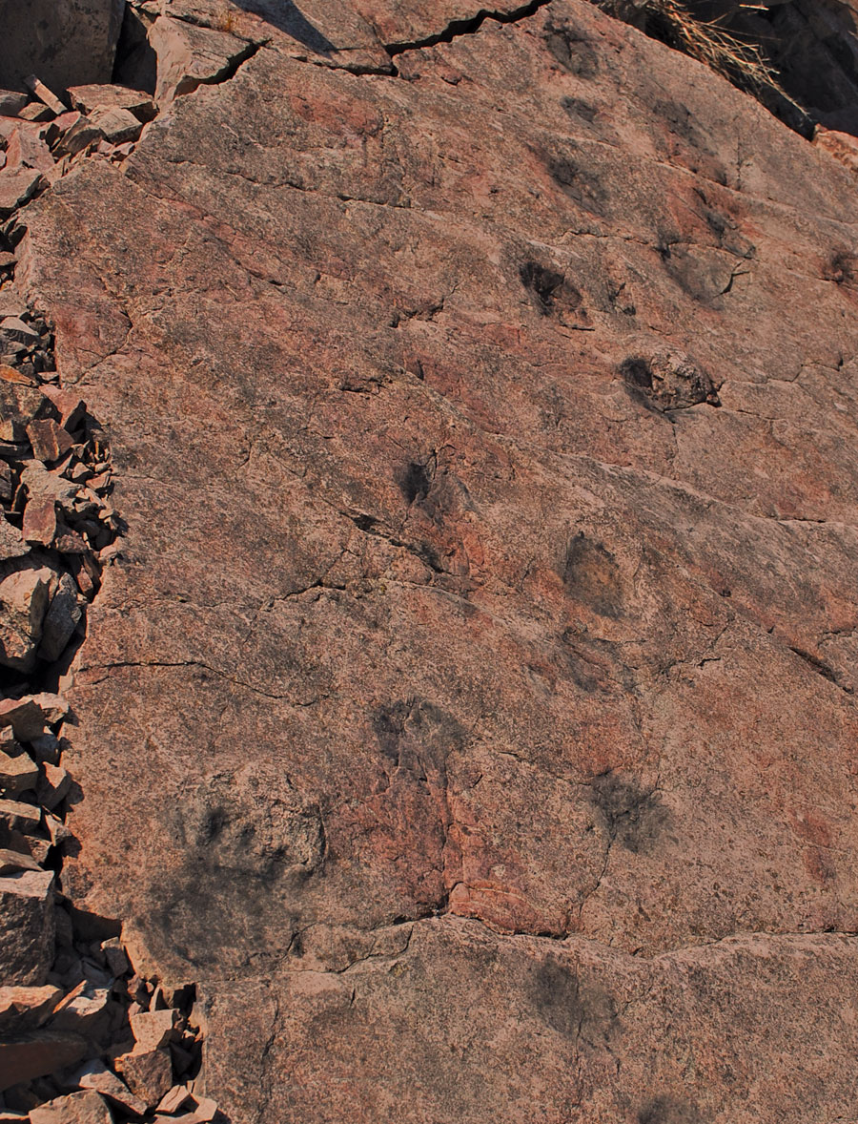Limestone slab from Poland with fossil footprints.
Another indication that the evolutionary story is flawed is the huge number of living fossils. That is, creatures that have been found in the fossil record have been assigned ages of hundreds of millions of years, yet are identical to creatures alive today. Dr Carl Werner has documented museum displays showing how many modern animals are found in dinosaur-era layers. Dr Werner said:
Fossil photo: Joachim Scheven, Lebendige Vorwelt Museum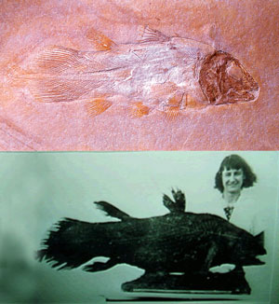Living coelacanth photo from Wikipedia.org
“I found representative examples from all of the major animal phyla living today and all of the major plant divisions living today. Taking it one step further, within these bigger groups, I frequently found representatives of all the major groups or classes within a phylum.”
But if all these animals are found in dinosaur-era layers, what has evolution been doing for the last hundred million years? For example, if apes eventually became humans in just 6 million years, how, with ever-changing ecological pressures, can there be so many plants and animals that are basically unchanged from their forms supposedly millions of years ago?
For instance, the Wollemi pine was supposed to have thrived around 150 million years ago and to have been long extinct, but in 1994, they were found growing in a forest in New South Wales, Australia. Even evolutionists claimed it was “like finding a live dinosaur”. And the coelacanth was supposed to have gone extinct around the same time as the dinosaurs, but we know that this deep-sea fish is still living because fishermen have caught them and National Geographic has filmed them swimming around!

The ‘Cambrian explosion’ is an out-of-order problem for evolutionists?
Bill Nye actually did creationists a favour by inadvertently pointing out a major weak spot for evolution.
In the Cambrian rocks (some of the alleged oldest complex-fossil-bearing rocks on earth—c. 500 plus myo), ‘index’ fossils of just about every major phylum can be found. Because next to no ancestors of these organisms appears below them, that is, they appear suddenly and simultaneously in the fossil record; it has long been a massive problem for evolutionists. As there is no smooth and gradual sequence to the appearance of these fossils, one could argue that the millions of creatures that represent the Cambrian explosion are out-of-sequence fossils by the evolutionists ‘own measure’.

There are many exceptions to the neatly portrayed order of the fossil record
In fact, the more fossils we find, the more random the picture becomes. This does not fit the orderly progression of ever-evolving specimens that evolutionists would predict. But it does fit very well with the creationist narrative of plants and animals created “according to their kinds”, and buried in a worldwide catastrophe.
Bill Nye actually did creationists a favour by inadvertently pointing out a major weak spot for evolution. In fact, the fossil record is evidence against Bill Nye’s position, and certainly evolutionists might want to think twice before drawing attention to such a vulnerable chink in their armor!

How the Joggins polystrate fossils falsify long ages
by Paul Price
Tas Walker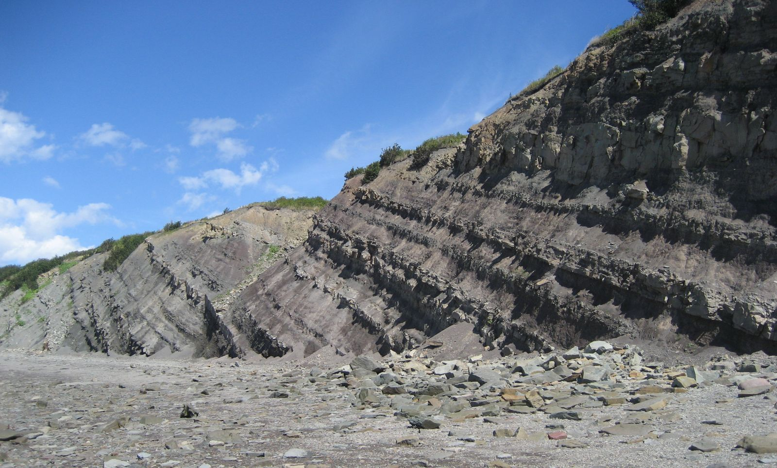Figure 1. The Joggins Fossil Cliffs of tilted Pennsylvanian sediments in the Bay of Fundy, Nova Scotia.
Polystrate fossils punch vertically through multiple layers, or strata, within a geological formation. They have been a mainstay of the debates in geology going all the way back to the earliest days of the deep-time controversy arising in the 18th century. They remain relevant to the discussion today.
In the 1800s, the primary debate over geology was waged between the competing ideologies of uniformitarianism and catastrophism. The former believed in slow gradual processes and long time periods, while the latter believed in rapid processes over short time periods. For a while, uniformitarianism was the dominant view. Today, however, the preferred term by long-age geologists is ‘actualism’, as they have been forced by the overwhelming evidence to abandon strict, classical uniformitarianism (a.k.a. gradualism) and include catastrophes to explain many parts of the geological record.¹

A quiet reversal
The fact that uniformitarianism (a denial of rapid catastrophes) has failed to explain much of the geological record can be seen as a great victory for creationists, but predictably the mainstream scientific community has refused to acknowledge this. And it is still heavily weighted towards ‘slow and gradual’, and strongly opposed to biblical catastrophism/diluvialism. According to Alan Cvancara,
“But a uniformity of causes does not imply a uniformity of rates, intensities, conditions, or results. … Some people consider actualism a better term than uniformitarianism. Processes that actually operate now, or those inferred to operate, can explain features and events of the past.”²
Ian Juby: ianjuby.org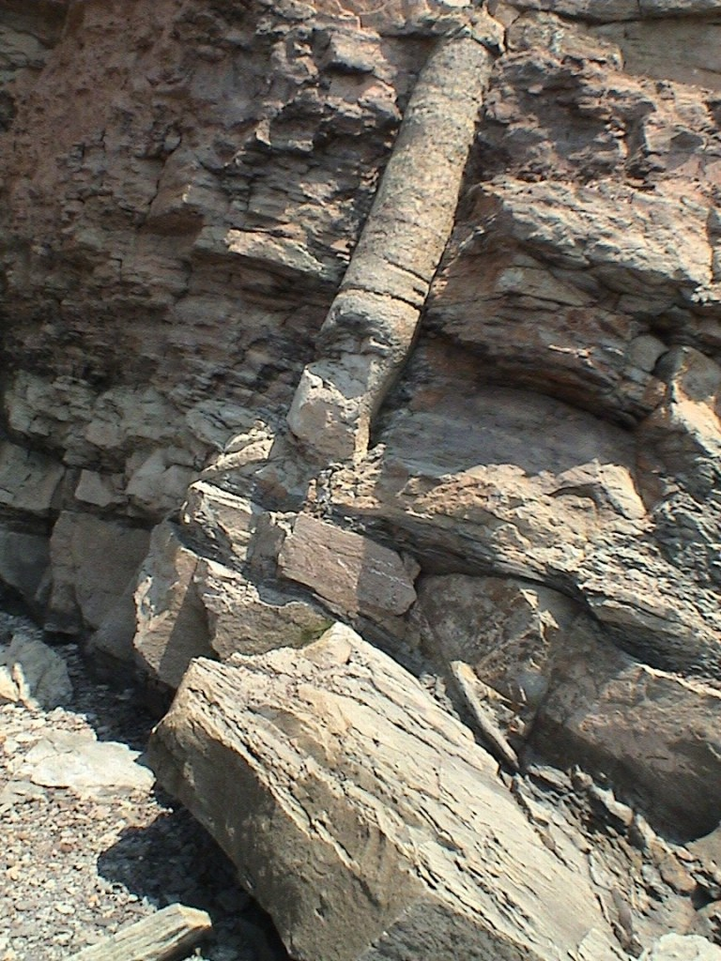Figure 2. Polystrate lycopod tree trunk extending through multiple sedimentary strata at Joggins Fossil Cliffs.
In one sense, adopting this means there is no singular explanatory framework in geology—secular geologists are free to adopt any explanation, be it rapid or gradual, for any individual formation. They might like to regard it as ‘looking for the best explanation for every situation’. But considering the long history of opposition to the overwhelming evidence for Flood geology, it tends to look a lot like special pleading, when strata in one area are viewed as being catastrophically deposited, while similar-looking strata elsewhere are said to have been deposited gradually.
Nowhere is this phenomenon perhaps better illustrated than in the case of polystrate fossils. Since polystrate fossils protrude through multiple layers of sediment, even secular geologists are forced to admit these layers had to be deposited rapidly. This is even more striking when we are dealing with fossils of considerable height (e.g. polystrate trees and giant tree-like reeds called lycopods). For example, Dr. Derek Ager, former president of the British Geological Association, wrote, “Obviously sedimentation had to be very rapid to bury a tree in a standing position before it rotted and fell down.”³
In Joggins, Nova Scotia, we see beds of exposed strata, equivalent to three times the depth of Grand Canyon, that contain copious polystrate lycopod trunks.⁴ This undermines the general assumption that such huge swathes of strata were laid down gradually over millions of years. If this much sediment can be deposited rapidly, then where is the need to assume any deep time at all?

The fossils which must not be named
That these features are problematic for the secularist worldview is highlighted by the fact that they refuse to admit there is even a legitimate term for these types of fossils! If you search ‘polystrate fossils’ on Wikipedia, for example, you will be greeted with a subheading: “Creationist term for a fossil that extends through more than one geological stratum.”⁵ Interestingly, though, the article provides no alternative ‘secular term’ for them. So, apparently, they are the ‘fossils which must not be named’ as far as secular geologists are concerned.

Many floods are better than one?
Since polystrate fossils protrude through multiple layers of sediment, even secular geologists are forced to admit these layers had to be deposited rapidly.
Just as they do with countless other features of the fossil record, long-age geologists resort to invoking local catastrophes to explain these features, rather than admitting to one global flood. However, we should be quick to remind them that it is not enough to show that a series of floods (or catastrophes in general) works as well as one global flood to explain what we see. Rather, they should be held to the proper intellectual standard: they should be able to show evidence for multiple local floods and explain why that is a better explanation than a global flood. Otherwise, they are running afoul of the principle of good reasoning known as Ockham’s Razor: that one should never multiply explanations beyond what is required. If one flood will explain the evidence, then invoking multiple floods is superfluous.
Ockham’s Razor is sometimes misunderstood or oversimplified to mean that ‘the simplest explanation is right’. But more accurately, this principle simply means that one should not propose a needlessly complicated explanation for an effect whose cause is unknown. For example, if you find a red chair, it would be unnecessary to say, “This chair was painted green, then sanded down, and repainted red,” in the absence of any reason to think it was not simply painted red to begin with. In a similar way, if the evidence we find in geology can be explained by one flood, global in scope, then to suggest instead that it was produced by many thousands of smaller floods would be unwarranted.

Addressing the ‘multiple flood’ claims
Canadian Ian Juby, who has extensively researched the cliffs at Joggins through personal fieldwork, has done much to bolster the case for a global Flood and critique the ‘plurality of local floods’ hypothesis as an explanatory framework for polystrate fossils. He lists many reasons why this hypothesis doesn’t work to explain the evidence at Joggins in his chapter of the excellent book, Rock Solid Answers.⁴

Paleosols—‘ancient’ soil layers missing
One of the responses that deep-time apologists tend to use against the creationist interpretation of polystrate fossils is the claim that paleosols (ancient soil beds) have allegedly been found in layers containing polystrate fossils.⁶ This is supposed to demonstrate that they were buried in situ (where they grew). However, as Klevberg et al. argue, the identification of paleosols is actually rather subjective.⁷
While this fact alone should give pause to those attempting to use this argument against creationists, we need not chase that rabbit, because in the case of Joggins, even long-age geologists freely admit that there is an absence of mature paleosols at the site. Davies et al. wrote, “The absence of highly mature palaeosols from the Joggins Formation is an accordance with near-continuous accumulation.”⁸
This is in stark contrast to the current explanation for these polystrate lycopods—that short bursts of rapid flood sedimentation punctuated much longer periods of inactivity. Ager, in his attempt to explain polystrate fossils at a different site in England, wrote, “… we cannot escape the conclusion that sedimentation was at times very rapid indeed and that at other times there were long breaks in sedimentation, though it looks both uniform and continuous.”³ That sort of thinking is not supported by the evidence at Joggins, however, even by the standards employed by secular geologists themselves. If these polystrate fossils were buried right where they grew in a series of flash floods, then why don’t we find evidence of mature soil, especially when there is good reason to think that soil layers don’t take long periods of time to develop?⁹

Inverted stumps
Ian Juby: ianjuby.org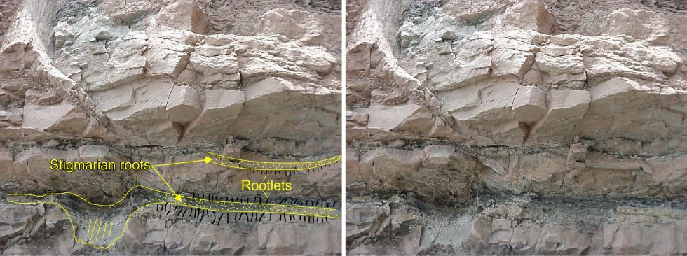Figure 3. Inverted tree trunk with roots.
Both Ian Juby and Harold Coffin¹⁰ have personally investigated the cliffs at Joggins and have documented the existence of upside-down stumps in the layers alongside the upright polystrate lycopods. If the stratum containing the base of the upright chutes is supposed to be an original, in situ soil bed, how can there be inverted stumps mixed in? We all know that plants don’t grow upside down! Critics have not contested the presence of these stumps,^{6,11} suggesting instead that local floods could have emplaced them. But if that were the case, we would expect to find them above the level of the buried (alleged) soil bed, not mixed in at the same level as the roots of the upright ones. Juby even documents one example of an inverted stump lying directly below an upright polystrate lycopod in the same stratum, with their roots intertwined.¹² We should never expect to see that sort of thing under the deep-time interpretation. Could that possibly be why we do not find any mention of these inverted stumps in the secular literature?¹³
Ian Juby: ianjuby.org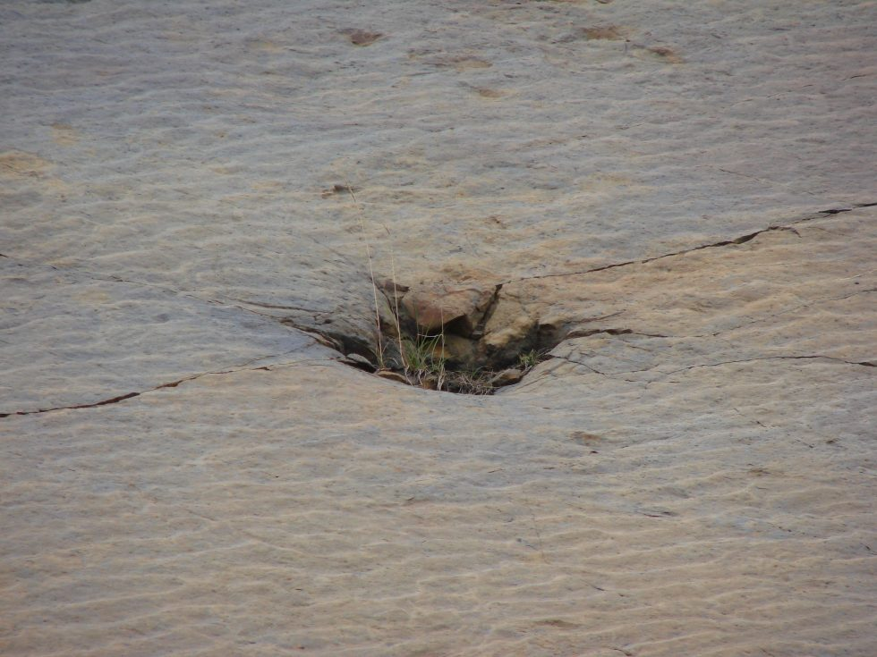Figure 4. Inverted tree trunk impression with ripples.
Dr. Stephen Godfrey, Curator of Paleontology at the Calvert Marine Museum in Solomons, Maryland, even addressed this on his website, but got it wrong:
“… all the trees are preserved right side up. In addition to which, the vast majority preserve their root system within the sediments in which they were growing. If the single flood hypothesis were correct, then I would expect some of the trees to have been entombed upside down. To my knowledge, no fossilized tree at Joggins has ever been found upside down!”¹⁴
Clearly Dr. Godfrey, who wrote this in 2017, long after both Coffin and Juby had published their findings, was ignoring the creationist sources on Joggins. If he had consulted them, it would have been hard to miss this important but mostly unreported fact.

Roots ‘growing’ upward
Ian Juby: ianjuby.org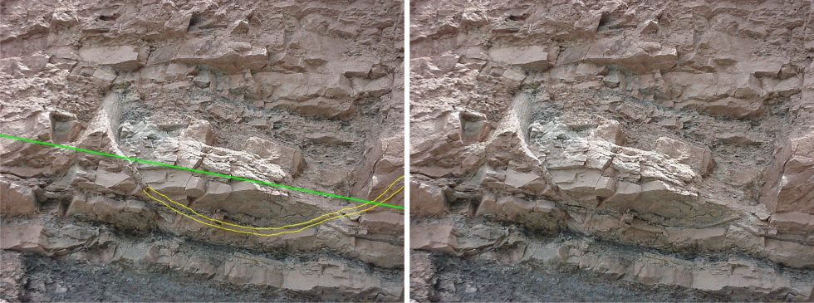Figure 5. Lycopod roots turned upward with their tips extending above the supposed soil horizon.
Another interesting feature of the lycopods at Joggins is ‘negative geotropism’ (the roots of some of the lycopods are turned upward and their tips extend above the supposed soil horizon).¹² Roots don’t tend to grow upward, as we all know, so why do we see this? Roots growing up above the level of the ‘soil’ doesn’t seem right at all. This would be better explained by the fact that these stumps were not buried in place, but rather were floating in muddy sediment and were rapidly buried. The layers are not ‘soil horizons’, but more likely represent the bands of sediment that we naturally see as a result of mechanical sorting in a flood scenario. Flume sedimentation experiments by creationist researcher Guy Berthault demonstrated this mechanical sorting effect clearly,¹⁵ and have since been recreated by secular researchers as well.¹⁶

Heavy pressures—and lizards?
Ian Juby: ianjuby.org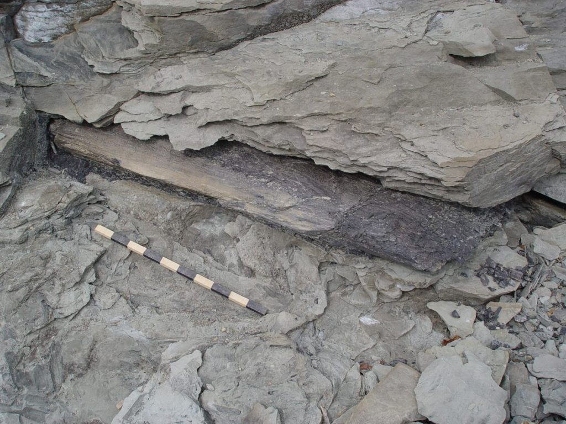Figure 6. Compressed fossil log.
There is another couple of interesting observations made at Joggins that support the single Flood hypothesis. Many of the fossil specimens there (the trees and lycopods and their preserved roots) have been crushed flat by extreme pressures. The amount of pressure needed to achieve this would have been immense. As Juby rhetorically asks, “How much pressure does it take to crush a log to half its original thickness?”¹⁷ But if the weight of overlying sediment only accumulated long after these polystrate specimens had fossilized (turned to stone), the pressure would not crush them. They had to be deformed while they were still relatively soft. Thus, these flattened fossils do not comport with smaller local flash floods, but they certainly do comport with a global flood.
As Juby rhetorically asks, “How much pressure does it take to crush a log to half its original thickness?”
And what of all the lizards? Many lizard fossil remains have been found inside some of the stumps, but these lizard bones are disarticulated (broken apart) and have also been flattened by immense pressure.¹⁷ Obviously, all this flattening (both of the lizards and the plants) had to happen before they were fossilized, because rocks do not bend; they break.

A clear overall picture of massive catastrophe
The case has never been stronger for a global Flood, and the cliffs at Joggins, Nova Scotia, reveal some of the most striking fossil finds in the world which support the Bible’s account of history. There will always be unanswered questions at Joggins—that is the nature of historical science. We cannot directly test the past, and our theories about what may have happened are always going to be limited to what we are able to conceive based upon what we have witnessed ourselves.¹⁸ Why are the giant reeds (lycopods) generally preserved upright, while nearly all of the actual trees are lying on their sides? Nobody can say for sure, but as Juby put it, “Not only are polystrate fossils found throughout the formation (indicating rapid, ongoing sedimentation), but the plants are giant hollow reeds which were undoubtedly more fragile than the fossil prostrate trees found also in the formation. Clearly, the hoary hypothesis of [long-agers Charles] Lyell and [William] Dawson cannot explain the Joggins fossils.”¹⁹

Where are all the human fossils?
by Andrew A. Snelling
What happened to all the people who were not on board Noah’s Ark? If there were many millions of people populating the earth at the time of the Flood as creationists have suggested, wouldn’t many of those people have been buried in Flood sediments? So why do we not find hundreds or even thousands of human fossils in the rock layers regarded as Flood sediments, with perhaps even some human fossils alongside, say, dinosaur fossils?
These are, of course, fair questions that are commonly asked. Because of our understanding of the Flood from the Scriptures, we might expect to find human fossils in Flood strata, so it is rather surprising, at first glance, that we don’t find any. However, Scripture (backed up by so much other evidence) is very clear that there was a global Flood and the pre-Flood people were destroyed, so there must obviously be an explanation for this lack of human fossils. Consequently, we are going to attempt an explanation by exploring possible processes during the Flood and logical deductions from present observations that could help us understand why there are no undisputed human fossils found in Flood strata.

Reported artefacts and skeletons
There are some claims and reports of human artefacts and remains in rock layers that are clearly part of the Flood sediments. However, many of these claims are not adequately documented in any scientific sense, while those few reports that have appeared in the scientific and related literature remain open to question or other interpretations. For example, the book Ancient Man: A Handbook of Puzzling Artifacts¹ looks like an impressive and voluminous collection of such evidence, but on closer examination many of the artefacts, though puzzling archaeologically, still belong to the post-Flood era, while other reports and claims are either antiquated or sketchy and amateurish.
Often lay scientists claiming to have found human artefacts or fossils have not recorded specific location details, so that professional scientists investigating the claims have had difficulty finding the location from which the sample in question came. ALSO, lay scientists have in the past not kept some of the rock which encloses the fossil or artefact as proof of its in situ occurrence. These two oversights have often made it well nigh impossible to reconstruct and/or prove where fossils or artefacts came from, thus rendering such finds virtually useless.
Fossilized hammers and supposed human footprints in ancient geological strata, regarded by evolutionists as deposited millions of years before man evolved, but regarded by creationists as Flood deposits, are extremely difficult to document scientifically above reproach and/or with any conclusive finality. (Merely finding rock around an implement does not prove it is pre-Flood.)
For example, it has been claimed that a gold chain was found in black coal.² However, the artefact evidently was exhibited as a clean gold chain with no coal clinging to it, so we see no evidence that the chain was actually found in the coal, just the claim that it was. While one would never assume any dishonesty on the part of the people concerned, because proper scientific procedures have not been followed the exhibit has proven to be almost useless in convincing a generally skeptical scientific community and apathetic lay public.
Should genuine human fossils or artefacts from the time of Noah’s Flood be found, then it is mandatory that proper scientific procedures be followed to document the geological context.
Thus, should genuine human fossils or artefacts from the time of Noah’s Flood be found, then it is mandatory that proper scientific procedures be followed to document the geological context, in order to guarantee that the scientific significance of such a find is unequivocally demonstrated. Regretfully, of course, the hardened skeptic would still remain unconvinced, but at least such a find may still awaken some in the apathetic public and a few of the more open-minded scientists.
What is needed, of course, are actual human bones fossilized in situ as an integral part of rock strata that are demonstrably ancient in evolutionary terms, and therefore are usually Flood sediments of the creationist framework for earth history. Yet here is where the real hard unequivocal evidence is lacking and why people ask the question ‘Where are all the human fossils?‘
We simply cannot point to the report of a human skull found in so-called Tertiary brown coal in Germany, for there is no definitive scientific report available on this object, even though its existence has been verified by the staff of the Mining Academy in Freiberg.³ If it is a coalified human skull, how is it possible to distinguish it from a clever carving in such a way that it becomes conclusive proof? Even if it were demonstrated as genuine, are we sure that the Tertiary brown coal in question was a Flood stratum? In some parts of the world some of the isolated so-called Tertiary sedimentary basins could easily be classified, according to some creationist geological schemes, as post-Flood strata. After all, the early Flood geologists, prior to the advent of Lyellian uniformitarianism and the evolutionary geological time-scale, applied the term ‘Tertiary’ to those rock strata that they believed to be post-Flood.
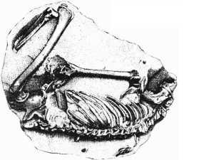A human skeleton, the Paris Museum specimen, found in limestone on the West Indies island of Guadeloupe. Controversy has raged over whether the limestone is ancient.
The controversial Guadeloupe skeletons are another case in point.⁴ Without wishing to take sides in the debate, and in any case the hard data are still inconclusive either way, the fact remains that even if perchance these skeletons were so-called Miocene, that in and of itself would still not prove that the skeletons were in Flood sediments and therefore represented the remains of pre-Flood people. Being a subdivision of the so-called Tertiary, these Miocene rocks may still be post-Flood sediments and so these Guadeloupe skeletons may still not be human fossils from Noah’s Flood.
Perhaps the fossilized human skeletons that come closest to having been pre-Flood humans buried in Flood strata are those skeletons found at Moab, Utah (USA).⁵ In a copper mine there, two definitely human skeletons were found in Cretaceous ‘age’ sandstone (supposedly more than 65 million years old), the bones still joined together naturally and stained green with copper carbonate. While many regard these bones as recently buried, there still remains the remote possibility that they are pre-Flood human ‘fossils’.
We can only concur that there is no definite unequivocal evidence of human remains in those rock strata that can definitely be identified as Flood sediments. This realization is at first rather perplexing. But some clues to unravelling this puzzle emerge on investigation.

The Nature of the Fossil Record
Let’s begin by considering the nature of the fossil record. Most people don’t realize that in terms of numbers of fossils 95% of the fossil record consists of shallow marine organisms such as corals and shellfish.⁶ Within the remaining 5%, 95% are all the algae and plant/tree fossils, including the vegetation that now makes up the trillions of tonnes of coal, and all the other invertebrate fossils including the insects. Thus the vertebrates (fish, amphibians, reptiles, birds and mammals) together make up very little of the fossil record—in fact, 5% of 5%, which is a mere 0.25% of the entire fossil record. So comparatively speaking there are very, very few amphibian, reptile, bird and mammal fossils, yet so much is often made of them. For example, the number of dinosaur skeletons in all the world’s museums (both public and university) totals only about 2,100.⁷ Furthermore, of this 0.25% of the fossil record which is vertebrates, only 1% of that 0.25% (or 0.0025%) are vertebrate fossils that consist of more than a single bone! For example, there’s only one Stegosaurus skull that has been found, and many of the horse species are each represented by only one specimen of one tooth!⁸
In any regional area where vertebrate fossils are found, there is a general tendency for these land animals to be higher up in the rock strata sequence on top of the strata containing marine organisms. This has been interpreted by evolutionists as representing the evolutionary sequence of life from marine invertebrates through fish and amphibians to the land-based vertebrates.
However, this same observation can be more reasonably explained by Flood geologists as due to the order of burial of the different ecological zones of organisms by the Flood waters. For example, shallow marine organisms/ ecological zones would be the first destroyed by the fountains of the great deep breaking open, with the erosional runoff from the land due to the torrential rainfall concurrently burying them. On this basis then we would probably not expect to find human remains in the early Flood strata, which would contain only shallow marine organisms. The fossil record as we understand it at the moment certainly fits with this.
Additionally, the majority of the few mammal fossils in the fossil record are in the so-called Tertiary strata, which most creationist geologists nowadays regard as post-Flood strata. If this is the case, then there really aren’t very many mammal fossils in the late Flood sediments (there are a few mammal fossils in the so-called Mesozoic rocks). Consequently, it’s not only human fossils that are not found in the Flood sediments, but there is a relative lack of other mammal fossils also.
Another problem in the fossil record is, as we have already seen, the fragmentary nature of what is often found.
Of course, in the post-Flood era humans would have been able to make the necessary decisions to get away from the local residual catastrophes responsible for the post-Flood (Tertiary) strata, so we wouldn’t expect to find humans fossilized in post-Flood sediments like we find other mammals.
Another problem in the fossil record is, as we have already seen, the fragmentary nature of what is often found, which makes identification difficult. For example, ‘a five million year-old piece of bone that was thought to be the collarbone of a human like creature is actually part of a dolphin rib…’⁹ Such genuine mistakes are inevitable when only fragments of bone are recovered from the rocks. We can’t even be sure that some bone fragments already found in Flood sediments aren’t in fact human remains, having been labelled something else by evolutionists. After all, because of their evolutionary molecules-to-man belief (bias) they don’t expect to find human remains in lower (older) strata.

Differential Mobility
Another factor to be considered is the differential mobility of humans and many land-dwelling animals compared to much of the abundant marine life, such as corals, barnacles and shellfish. When the Flood began, the rising Flood waters would probably have encouraged humans and mobile land animals to preferentially move away from low lying areas to higher ground. Thus their being swept away by the Flood waters would probably have been postponed (perhaps for weeks) until all the high ground also was covered.
Consequently, we would predict that it would be highly unlikely for us to find human fossils now in sediments that were deposited early in the Flood year. Indeed, when we look at the fossil record, as we have already seen, we find that in the so-called Paleozoic strata there is a preponderance of marine creatures, beginning with trilobites, corals, sea anemones, shellfish of all types, etc. This is what we would predict, given that the Flood waters carried sediments from the land out to the sea where they would then be deposited, burying many of the relatively immobile seafloor-dwelling creatures, followed later by destruction and burial of fish. Thus it is not surprising that we see the land-dwelling animals being preserved later in the fossil record, where they would have been buried later in the Flood year as the rising Flood waters finally covered the land surface completely.

Destruction of Skeletons
The next question to ask is: Would all the people still be alive when the Flood waters finally covered all the land and swept them away be buried and preserved as fossils in the later Flood sediments? Can we assume that there was no destruction of the people’s bodies in the Flood waters and by other processes operating during the Flood and subsequently? Probably not!
The turbulence of the water, even in a local flood, can be horrific, particularly when the fast-moving current picks up not only sand and mud, but large boulders. Under such conditions, human bodies would probably be thrown around like flotsam and would tend to be destroyed by the agitation and abrasion.
But even if human bodies were buried in the later Flood sediments, destruction could still occur subsequently (that is, post-deposition). For example, if ground waters permeating through the sediments (such as sandstone) contain sufficient oxygen, then the oxygen would probably oxidize the organic molecules in the buried bodies and so destroy them. (This could be regarded as a type of weathering.) Likewise, chemically active ground waters could also be capable of dissolving human bones, removing all trace of buried people.
Many Flood sediments have also undergone chemical and mineralogical changes due to the temperatures and pressures of burial, plus the presence of the water trapped in between the sediment grains.
Many Flood sediments have also undergone chemical and mineralogical changes due to the temperatures and pressures of burial, plus the presence of the water trapped in between the sediment grains. This process of change, known technically as metamorphism, eventually obliterates many fossils in the original sediments, whether they be fossils of shellfish, corals or mammals, particularly with increasing depth of burial, and higher temperatures and pressures.
Yet another process that could destroy buried human bodies would be the intrusion of molten (igneous) rock into the Flood sediments, and through them to the surface to form volcanoes and lava flows. Such processes involve heat intense enough to melt rocks and recrystallize them. As the hot molten rock rises through the sediments, the sediments are often baked by the heat, and again chemical and mineralogical changes occur that obliterate many contained fossils. All of these factors greatly lengthen the odds of finding a human fossil today.

Differential Suspension
Not only would the turbulence of the sediment-laden Flood waters probably destroy some of the human bodies swept away, but differential suspension in the waters could have made it hard to bury those bodies that survived the turbulence. This is because human bodies when immersed in water tend to bloat, and therefore become lighter and float to the surface. This is what is meant by differential suspension. The human bodies floating on the water surface could therefore for some time be carrion for whatever birds were still flying around seeking places to land and food to eat. Likewise, marine carnivores still alive in their watery habitat would also devour corpses.
Furthermore, if the bodies floated long enough and were not eaten as carrion, then they would still have tended to either decompose or be battered to destruction on and in the waters before any burial could take place. This could explain why we still don’t find human fossils higher up in the fossil record/geological column, that is, the later Flood sediments.
When we take all these factors into account, it would seem unlikely that many of the people present at the time the Flood waters came could have ended up being fossilized. Even if a handful, perhaps a few thousand, were preserved, when such a small number is distributed through the vast volume of Flood sediments, the chances of one being found at the surface are mathematically very, very low, let alone of being found by a professional scientist who could recognize its significance and document it properly.
Putting all these factors together and assuming that they are all realistic possibilities, then the probability of finding a human fossil in the Flood sediments today would be very, very small. To date, our investigations of the fossil record indicate that there are no human fossils in Flood strata, so perhaps the above explanations could be some of the reasons why this is so.

The Purpose of the Flood
Finally, however, we need to consider the purpose for which God sent the Flood, for this provides yet another reason, and perhaps the main reason, why we do not find any human fossils in the Flood sediments and why we should not expect to find any. In Genesis 6:7 we read that God said He would destroy man whom He had created from the face of the earth. So perhaps God deliberately made sure that the Flood waters did just that, destroying every trace of man and his artefacts from the pre-Flood world, if this is what He meant by what He had recorded in the Scriptures.
Yes, God did say that He would send a Flood to destroy the beasts of the field and every living thing in whose nostrils was the breath of life also, but yet we find fossils of all the animals, etc. How then can it be that we find animal fossils and not human fossils or artefacts, when God said that He was equally going to destroy the animals and man from the face of the earth by the Flood?
Photo by Billy Nungesser/WWL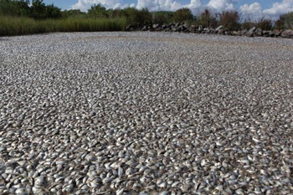Figure 1. Massive floating fish grave in Louisiana shows fish bodies don’t sit underwater waiting to be fossilized.
Elsewhere in Scripture we learn that as far as God’s judgment of sin is concerned, when God says that He wants the offenders removed, then this means utter destruction. We see this in the case of the children of Israel moving into the Promised Land. They were told to utterly destroy the Canaanites because of their evil and evil practices. God had pronounced judgment on the Canaanites and the Israelites were but His instruments in executing judgment. The fact that they didn’t utterly destroy the Canaanites ended up being a lingering malignant problem, as the Israelites repeatedly lapsed into the sinful practices of the Canaanites who had survived the conquest.
Similarly, we see that God issued the instruction to King Saul to utterly destroy the Amalekites, again as a judgment on them for their evil (1 Samuel 15:3). Again, when God meant His judgment to be utter destruction, He meant what He said, and Saul’s disobedience in not carrying through this instruction led to his own downfall.
It would seem to us unloving of God to execute such relentless judgment, but such is God’s abhorrence of sin that its penalty must be seen for what it is—utter destruction and removal of all trace. If God cannot tolerate sin (His holiness cannot ‘look’ on sin), then all trace of sin has to be removed in judgment, which necessitates utter destruction. Should human remains have been allowed to survive the Flood as fossils, then there could also have been the possibility of such remains being worshiped and revered.
However, at least some of the animals became fossilized. Though Genesis 6:5-7 implies that they were affected by the entry of sin into the world, they were not morally accountable. Also, they serve as a witness to God’s judgment at the time of the Flood. In other words, when we look at the fossil record and seem not to see any human fossils, this should remind us how much God hates sin. We should see the fossils as a sober reminder of the penalty of sin and the character of God’s judgment, and as a testimony to the reality of Noah’s Flood and the trustworthiness of the Scriptural record.
The Apostle Peter takes up this theme in 2 Peter 3:7. He says that just as God created the world and judged the world the first time by the Flood, then so too He is going to keep His word and judge the world the second time by fire. Man therefore should take heed and make peace with his Creator while there is still time, before God comes again as Judge with sudden and swift judgment.

Conclusions
As far as we are aware at the present time, there are no indisputable human fossils in the fossil record that we could say belong to the pre-Flood human culture(s). When we endeavour to understand some of the processes that may have occurred during the Flood, and also the real nature of the fossil record, we are not embarrassed by the seeming lack of human fossils.
We don’t have all the explanations as to how the evidence came to be that way, and it may be that in the future we will discover some human fossils. However, there is also much about the fossil record that the evolutionists have a hard time explaining. On the other hand, we should also realize that we don’t have all the answers either, and we never will.
Even though God has left us with evidence for creation and the Flood, the Bible still says that without faith it is impossible to please and believe Him (Hebrews 11:6). Because we weren’t there at the time of the Flood we cannot scientifically prove exactly what happened, so there will always be aspects that will involve our faith. However, it is not blind faith. As we have investigated the evidence, we have seen nothing to contradict what the Bible says about a world Flood. We can be satisfied that there are reasonable explanations, consistent with Scripture, for the seeming lack of human fossils in Flood rocks.

Fossils in a day?
by Ron Neller
Paleontologists (fossil experts) traditionally believe that time—lots of it—is an essential ingredient to form fossils. But a paper by three scientists in the online journal Palaeontology indicates they may well have created fossils in a single day.
Palaeontology, 2018 p. 5 … used with permission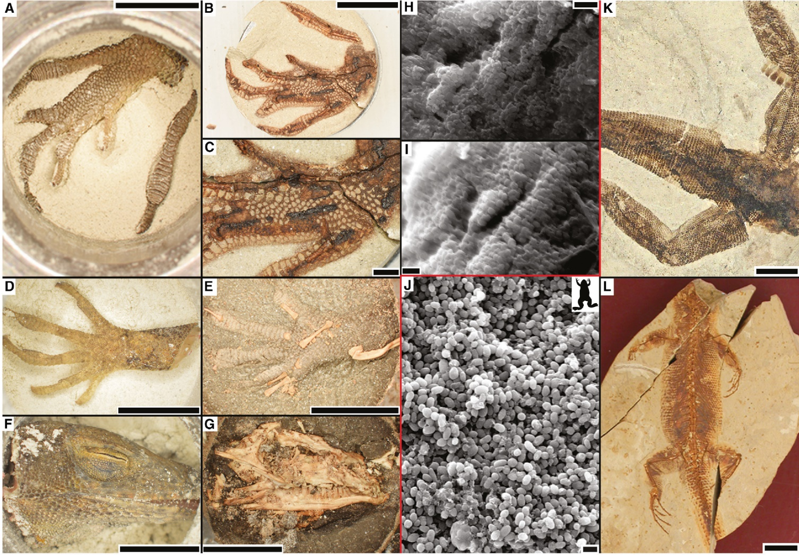 A collation of experimental (before burial) and maturation images of a lizard. Images A, D and F represent experimental lizard foot, hand and head, whilst images B, C, E and G are maturation images of the same. In comparison, K and L are actual lizard fossils. H and I show exposed melanosomes, bodies that make and store melanin (for colour and photoprotection); J shows fossil melanosomes.
A summary of their paper is titled: “Researchers have discovered how to make proper fossils—in a day”. It says they “figured out a way—by compressing that incredibly lengthy process into a day.”
But equally important is that the research undertaken highlights the importance of sediment in fossil formation.
Taphonomy is a field within paleontology that studies the chemical and physical processes of decay and fossilization. Such scientists have long recognized that heat and pressure are especially necessary ingredients for forming fossils. Of course, there is plenty of pressure on deep sediments, and in addition to the heating associated with this there are also many lava flows throughout the fossil record.
To experimentally mimic the fossilization process, taphonomists have undertaken what they call maturation experiments. These often involve placing an organic specimen (say a leaf or feather) in a small sealed capsule and then heating and pressurizing the contents. These experiments are meant to speed up the rate of chemical degradation and shorten the time for fossil formation.
In the Palaeontology paper, the researchers noted that traditional maturation experiments face challenges. One of the more significant of these is that labile molecules (relatively unstable substances that are readily changed or broken down) and volatile molecules (those which readily evaporate) should be lost during maturation, but are instead trapped inside the holding capsule. As a result, an organic specimen can become more of a soft, spongy ‘mush’ than anything like a fossil.
So these three scientists decided on what they called a ‘novel’ approach. They first buried the organic specimens within easily-compacted clay, and then applied pressure to make a ‘tablet’ of clay with the specimen inside. These tablets were then placed inside the capsules.
The purpose was to explore more closely what is stable and what is mobile—what is trapped in the compacted specimen, and what escapes into the sediment. They called this an “initial compaction in sediment, followed by maturation [temperature and pressure].”¹
The outcomes were fascinating. According to the Science Alert article, the bird feathers, leaves, resin and other substances were “spectacularly well preserved”. It quotes lead author Saitta as saying:
We were absolutely thrilled. … They looked like real fossils—there were dark films of skin and scales, the bones became browned. Even by eye, they looked right.²
The Palaeontology paper argues:
In this procedure, porous sediment allows maturation breakdown products to escape into the sediment and maturation chamber, while recalcitrant, immobile components are contained, more closely mimicking the natural conditions of fossilization.¹
Simply put, “unstable molecules … leak out into the sediment, instead of turning the entire fossil to mush.”¹
Their paper goes on to explore the utility of this approach and its implications in explaining the many exceptionally-preserved fossils in the rock record (their origin is a topic of great debate among experts).
Such aspects are certainly worthy of further exploration. But equally important is that the research undertaken highlights the importance of sediment in fossil formation.

Needed—rapid burial
First, the scientists confirm that sediment plays an important role in removing unstable and volatile molecules that would otherwise prevent fossilization.
Second, their results highlight a need to more thoroughly study the sediment—what are its origins, how abundant is the sediment, sediment movement and deposition—because rapidly deposited sediments are needed to induce the pressure needed.³
In short, current surface processes of erosion and deposition of sediments cannot explain the billions of fossils found globally.
After many decades of measuring sediment loads and sedimentation rates around the globe (part of my own professional field of interest), we find that in all climatic environments they are remarkably low. Instantaneous deposits from flooding rivers are typically only millimetres or centimetres deep, not the metres or tens of metres needed to induce pressure to speed chemical degradation.
In short, current surface processes of erosion and deposition of sediments cannot explain the billions of fossils found globally. What was needed was a flood of unprecedented magnitude, capable of providing vast quantities of sediment over a short time period.⁴
These recent experimental results support the description of the global Flood of Noah in Genesis 6–8. This would have provided unprecedented rapid burial in deep sediment that was able to remove unstable and volatile molecules and cause the pressure needed for extensive organic fossil preservation—without millions of years.

Hundreds of jellyfish fossils!
by David Catchpoole
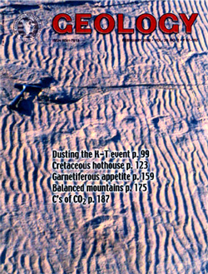Evolutionary stories
The journal Geology carried the story our article comments on. Many observations at this fossil site better support the idea of large-scale flooding and fast sediment build-up. However, in the original article, a ‘slow and gradual’ evolutionary story is offered instead—because it fits with the current reigning evolutionary paradigm?
What a storm it must have been! News reports said that hundreds of giant jellyfish once lived about 500 million years ago, but were ‘stranded by a freakish tide or storm’ on an ancient beach. Sand later buried them, forming fossils.^{1,2} With many specimens measuring over 50 cm (20 in) across, these are the biggest fossil jellyfish known.
Found in a Wisconsin sandstone quarry, it must have been an extraordinary set of circumstances that preserved them, geologists say, for fossilized impressions of jellyfish, which have no skeleton or other hard parts, are extremely uncommon.³
‘Preservation of a soft-bodied organism is incredibly rare, but a whole deposit of them is like finding your own vein of gold’, said James Hagadorn, one of the paleontologists who reported the find.^{1,4}
Also remarkable is that the rock was sandstone (i.e. the jellyfish were buried in sand which later ‘cemented’ into rock), rather than fine-grained rock like mudstone. In sand, buried jellyfish quickly break down because oxygen readily filters through interconnected air spaces between sand grains, allowing rapid decay.
But in fine-grained settings, Dr Hagadorn and his colleagues explain that ‘catastrophic burial and stagnation’ inhibit decay; therefore, jellyfish are more readily preserved. ‘You never get soft bodied preservation in that kind of coarse grain size’, Hagadorn says excitedly.⁵ ‘When people find a T-rex, that doesn’t excite me that much, because a T-rex has bones and teeth—really easy to fossilize. But to preserve a jellyfish, that’s hard, because it has no hard parts. Something is there we don’t understand.’
The ‘storm tide’ scenario proposed by James Hagadorn and his colleagues seems at first to explain some of the puzzle. They point out that when jellyfish are stranded on beaches today, they quickly fall prey to scavenging predators such as birds and beach-dwelling crustaceans.
So why didn’t scavengers rip into these stranded jellyfish? The answer, say the paleontologists, is that these fossils are over half a billion years old, i.e. they lived before land animals and birds had evolved. New Scientist explained, ‘Because there were not any birds back then, the carcasses remained stranded until they were buried by subsequent storms.’⁶
So their preservation is attributed to the absence of scavengers and that the jellyfish were buried soon after they were stranded. But note that this ‘explanation’ for the absence of scavengers assumes that evolution is demonstrated fact—which it most certainly isn’t. And these jellyfish fossils certainly don’t support the idea of burial over millions of years either.

The evidence doesn’t fit
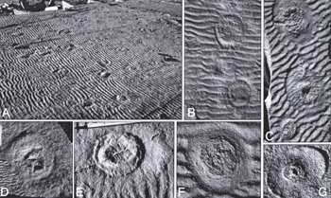
A scanned copy of Hagadorn et al.’s Figure 3 on page 149 of Geology journal, February 2002,^{4,7} gives us a closer look at the evidence and we can determine how well their interpretation fits. The figures reveal a number of puzzles which the ‘multiple storm tide’ scenario does not satisfactorily explain:
- The presence of beautifully-preserved ripples, so obviously evident in photographs A–F, is a major difficulty for the jellyfish-stranded-by-ebbing-tide story. Sand ripples are formed by flowing water, but when the tide recedes, the swash and backwash of waves on the beach completely obliterates any sand ripples formed earlier. Yet the Hagadorn et al. theory proposes that there were (a) multiple tidal cycles (vertical range approx. 1–2 m (3–6 ft)) before the jellyfish were buried under layers of sediment deposited each time the tide returned, and (b) waves (generated by wind). Clearly, the story doesn’t fit the evidence.
- The paleontologists conclude that the ‘multiple generations of ripples’ (photo C) in the first few layers of sediment in and around jellyfish impressions, together with the absence of ripples within the central area of each impression (B–G), indicates that jellyfish carcasses remained intact through multiple tidal cycles.
But today, whenever an ebbing tide leaves stranded jellyfish exposed to drying air and sun, the carcasses shrink and the stomach cavity collapses—i.e. today’s jellyfish carcasses do not remain ‘intact’ as the fossil jellyfish did. To try to explain this puzzle, the paleontologists suggest that perhaps the fossil jellyfish carcasses reabsorbed water (thus expanding back to their original size) each time the tide returned. But this is really stretching the ‘multiple tides’ story to try to make it fit the evidence. Instead, the evidence rather seems to show that the fossilized jellyfish were under water continuously as they were being buried under layers of sediment.
What a storm that must have been!
- A major problem for the paleontologists’ scenario is that, today, when masses of jellyfish are stranded by a storm etc., they commonly pump their bells to try to escape. But the tell-tale ‘concave rings’ of sediment resulting from the bell contractions of dying jellyfish, as seen on beaches today, are absent in nearly all these fossil impressions. It would seem that the paleontologists are correct to surmise that most of the jellyfish were dead or didn’t pulse, but their ‘beach stranding’ scenario does not explain why.
- In the quarry, the paleontologists found that ‘at least seven flat-lying planar bed surfaces contain hundreds of medusae [jellyfish] impressions’ (our emphasis). And the depth of these fossil-bearing bands of sediment from the lowest jellyfish fossil layer to the highest was several metres (about 12 ft). What a storm that must have been! Actually, Hagadorn et al. invoke ‘severe tropical storms’ (implying more than one storm) as the cause of jellyfish stranding, but their paper avoids any mention of a time period. (In newspaper reports though, Hagadorn is reported to have said that the fossilized jellyfish were ‘encased in about 12 vertical feet of rock representing a span of time up to 1 million years’.²) Was it one storm every hundred thousand years or so, for a million years? If the storm tide scenario cannot satisfactorily explain the jellyfish fossils in one of the sediment beds, how much more difficult would it be to explain seven? And in each case, the fossils have been beautifully preserved.
Image credit: AP Photo / Reed Saxon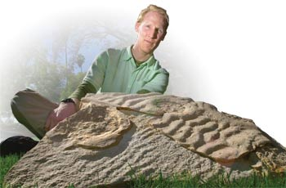The fossils that shouldn’t be there
Paleontologist Dr James Hagadorn displays fossilized jellyfish in rock taken from a sandstone quarry in Wisconsin, USA. He suspects that ‘hordes of other fossilized jellies’ await discovery worldwide.

A better alternative: smothered in the Flood!
The evidence makes much more sense from a biblical Flood perspective:
- The preservation of the sand ripples is easily explained. Being at depth rather than in a tidal zone, waves did not erode the sand ripples. Also, ripples can only be preserved when covered by a different type of sediment—in this case, the ripples in coarse sand were overlain by a finer silty sand and red oxidized mud.
Such a starkly different type of sediment is much more likely to have been carried and deposited by swirling floodwaters than by a returning tide in a beach environment.
- The multiple layers of ripples (and the variation in their alignment/orientation between layers) reflect their having been laid down by sediment-laden currents of varying strength (thus the variation in particle sizes between layers).
This is much easier to imagine with swirling, surging floodwaters flowing over the continents than within the confines of a beach environment over millions of years.
- The likely reason why ‘The majority of jellyfish were dead or did not pulse, …’ is that they were overcome quickly by sediment-laden water, smothered under layer-upon-layer of sand and silt. So most had no chance to exhibit the usual beach-stranding ‘escape behaviour’ (hence the absence of concave sediment rings). Interestingly, Hagadorn et al. suggest that the asymmetrical steepened edges of the convex ring in photo G ‘perhaps reflect’ an effort to escape stranding. But might this actually reflect the jellyfish’s attempt to escape from being buried (by an underwater avalanche of silt) rather than from being stranded on a beach?
- The evidence indicating that the jellyfish did not dry out fits better with their being buried while continuously under water.
- The absence of any evidence of scavenging was not due to beach-dwelling scavengers having not yet evolved, but to the jellyfish having been covered by sediment quickly.
- The lack of any evidence of burrowing by worms etc. in the sediment shows that these layers were buried quickly underneath the overlying layers of sediment—consistent with the global Flood.
Probably many more jellyfish impressions remain concealed within the quarry rocks
- The seven sediment bands of jellyfish fossils, across several metres (about 12 ft) of layers, are readily explained by the biblical Flood. (And remember that seven beds are all that we can see—probably many more jellyfish impressions remain concealed within the quarry rocks.)
Jellyfish are essentially floaters, at the mercy of strong currents, and perhaps in the fast-moving, sediment-carrying waters of the Flood (Genesis 7:11), the bell-pumping action of jellyfish would have pumped silt/sand/mud into their stomachs and internal cavities, and as their sediment load increased, they would have progressively sunk to the sea bed, being quickly buried as layers of sediment built up. This also seems to fit with the carcasses all facing the same direction when they were buried, much better than does the Hagadorn et al. ‘storm tide’ scenario.
So, the evidence fits with the biblical Flood, not with Dr Hagadorn’s storm tide.⁸ As one science commentator said of stranded jellyfish:
‘Waves and sand destroy their bodies before they can be covered in sediment—essential for the slow process of fossilization.’⁹
But the long-age uniformitarian idea that the fossils are formed by sediments slowly covering up dead animals does not describe how these jellyfish fossils could have been preserved.
No wonder Charles Darwin, with his uniformitarian thinking, wrote, ‘No organism wholly soft can be preserved.’¹⁰
With all these hundreds of jellyfish fossils in a Wisconsin quarry, I wonder what Darwin would say now?

DNA dating—positive evidence that the fossils are young
by Carl Wieland
DNA, the complex molecule of heredity, can be observed in the laboratory to hydrolyse (break down) by itself. We have already commented in Creation magazine on the discovery of DNA in magnolia leaf fossils which are supposed to be around 20 million years old according to evolutionary assumptions, and suggested that this seemed rather unbelievable for a complicated molecule which progressively disintegrates all by itself (Vol. 13 No. 2, pp. 22–23).
Now Brian Sykes in the prestigious journal Nature clearly states that the rate at which DNA breaks down in the laboratory is such that after 10,000 years no DNA should be left. Writing about the magnolia leaf fossils (and others in the same ‘ancient’ layer found to also have DNA, including oak, cypress and tulip tree fossils) he says:
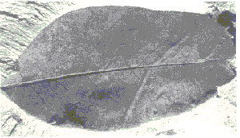Finding DNA in magnolia leaf fossils calls into question the long ages assigned to these fossils by evolutionists.
‘This means these compression fossils defy the prediction, from in vitro estimates of the rate of spontaneous hydrolysis, that no DNA would remain intact much beyond 10,000 years. What a good job not everybody knew that, grant reviewers included.’¹
One can clearly see the following sequence of logic in evolutionary circles, which is important to keep in mind now that we are seeing more and more reports of ‘ancient’ DNA (and proteins).
- In the absence of the repair machinery of a living cell, DNA breaks down, by itself, at an observed, measurable rate which would mean that after 10,000 years there should be none left.
- Therefore, any specimen which has DNA still in it cannot be more than 10,000 years old.
However:
- Intact DNA has been found in specimens which evolutionists ‘know’ to be millions of years old. (Because it is found in lavers which, according to the geological age-dating system, are assigned this age—17–20 million years in the case of the plant fossils mentioned here.)
- If this system of vast ages is not correct, the whole evolutionary scenario collapses.
- Therefore, the logical deduction in the first two points above (based on real science—that is, an observable process) must be flawed. There must be some special conditions which can somehow ‘hold up’ the breakdown of DNA quite dramatically.
Notice how point 3 brings in the assumption/belief that the vast evolutionary age assigned to these fossils is correct. That belief becomes the justification for discarding the prima facie implications of the laboratory data.
Creationists who maintain that none of the fossil-bearing layers are more than 10,000 years old can rightly view the finding of DNA in such layers as positive evidence for this assertion, until and unless there is some definite demonstration (apart from pre-existing belief in evolution’s long ages) of how any conceivable ‘special conditions’ can hold up the breakdown of this complicated, fragile chemical.

Fast fossils

Billions of well-preserved fossil fish clash with popular belief
by Carl Wieland
For most people, the two words ‘fast fossils’ don’t seem to go together. Say ‘fossils’, and they think ‘slow and gradual processes; millions of years’. Unfortunately, even though many leading evolutionists are now conceding that catastrophic, rapid processes are needed to explain many fossils, the average person is still left with this deeply-ingrained belief.
If the fossil record did take millions of years to form, then the Bible is wrong about the history of the earth and life on it. Fossils show death; there are also many instances of disease (see T-rex with gout, e.g.), violence and bloodshed evidenced in the fossil record. So, if these existed millions of years before there were people, then the Bible is wrong when it indicates that these ‘bad’ things are part of the Curse on creation, which only came about because of the rebellion of the first man, Adam, against his Creator.
However, the Bible is the very Word of God, affirmed as absolutely true by the Lord Jesus Christ (e.g. John 10:35). Thus, we can expect the evidence to be consistent with what the Bible teaches, regardless of how many people believe otherwise. According to the book of Genesis, there was a global catastrophe—a world flood which by implication was capable of burying billions of creatures rapidly in sedimentary layers.
So, reasoning from Scripture, we would expect that most fossils were formed by rapid processes. What does the evidence show?
... reasoning from Scripture, we would expect that most fossils were formed by rapid processes.
The fish fossil shown here [Ed. note: Due to copyright restrictions, the photo in the print version of this article could not be reproduced in the web version. Please see Creation 19(4):24–25, September 1997.] is a wonderfully preserved specimen. Though not all are as beautifully preserved as this one, there are literally billions of fish fossils in rocks around the world, so well preserved that they still show details such as scales, fin structure, etc. In fact, most people would have seen such fossil fish at one time or another.¹
What do these billions of well-preserved fossils fit—the common belief in slow and gradual processes, or the biblical implications of fast burial?
The easiest way to answer this is to imagine what happens to a fish when it dies. After (for most) floating on the surface while being attacked by various scavengers, what is left (if anything) sinks to the bottom. Here, rather than lying quietly for thousands of years being gradually covered up by slowly settling sediment, it will be attacked further by fish, crabs, and many other creatures.
Bacterial attack will also contribute to the process of disintegration. Even in a sterile, low oxygen environment, the flesh rapidly becomes soggy and falls apart,² leaving no trace of the beautiful structures which the fossil illustrated, for example, shows. That is why, when snorkelling on the sea floor, one does not see thousands of dead fish resting quietly on the ocean bottom in part-way stages of fossilization!
To preserve such features, it is obvious that the creature needs to be buried quickly. Not just that, but the enclosing sediment needs to harden fairly quickly. If it stayed soft and unconsolidated for years, the fact that oxygen, moisture and bacteria could easily access the carcass means that one would very quickly have a disintegrated, stinking mess. To try to imitate how such features as scales and fins can possibly be preserved, the best experimental analogy would be to bury a fish rapidly in wet cement!
How would hordes of fish be buried during the Flood? The upheavals necessarily associated with a year-long global Flood would generate ideal conditions for rapid sedimentation. Today, for example, localized earthquakes can trigger large submarine avalanches (called ‘turbidity currents’) which have been clocked as carrying millions of tonnes of sediment at over 50 kph (30 mph) underwater.³
The silent testimony of the billions of well-preserved fossil fish around the world is, by the most obvious common sense, to rapid processes—rapid burial and rapid hardening (of the encasing sediment). Sadly, the mindset of our culture is such that most people miss the obvious, and continue to think ‘slow and gradual’ when they see fossils—even beautifully preserved ones like this.

Evolutionists can’t dodge ‘Living Fossils’
by Don Batten
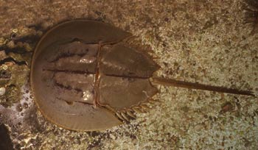
Modern Horseshoe Crab, Limulus polyphemus, World Aquarium, Missouri, USA
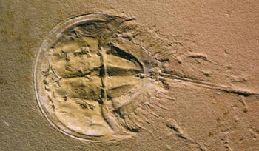
Dinosaur-Era (Jurassic) Horseshoe Crab, Mesolimulus walchi, Jura Museum, Germany
Despite the clear similarity of these horseshoe crabs, evolutionists insist on giving the fossil different genus and species names to its living counterpart. But where’s the difference? Note that the fossil specimen was found in rock labelled as “Jurassic”—said to date from 180–225 million years ago. Why is there no evolution (‘change’) in all that (supposed) time?
Some folk just don’t see the significance of the myriad examples of ‘living fossils’. Following our interview with Dr Carl Werner on the topic,¹ one evolutionist protested:
“There is no written rule that says a lineage has to die out just because an offspring develops a beneficial mutation. The theory of evolution explains how species change over time, it doesn’t say that all species must change over time. As long as a species can survive in its environment and pass on its genetic information to its offspring, it can survive indefinitely. It doesn’t mean that the ‘living fossil’ didn’t speciate, it just means those possible splits died out while the original lineage was able to always successfully reproduce even into today. How exactly does that not work with evolution?”
Evolution is about change, and putting ‘evolutionary’ in front of ‘stasis’, does not explain the stasis in terms of evolution.
However, as Dr Werner said in the article:
“If a scientist believes in evolution and sees fossils that look like modern organisms at the dinosaur digs, he/she might invent an hypothesis to ‘explain’ living fossils this way: ‘Yes I believe that animals have changed greatly over time (evolution), but some animals and plants were so well adapted to the environment that they did not need to change. So I am not bothered at all by living fossils.’ This added hypothesis says that some animals did not evolve. But if a theory can be so flexible, adding hypotheses that predict the opposite of your main theory, one could never disprove the theory. The theory then becomes unsinkable, and an unsinkable theory is not science.”¹
Furthermore, some evolutionists have admitted that living fossils (‘stasis’) are a big problem for evolution.² They have no explanation. This is not about suggesting that something has to go extinct if something evolves from it; that is not the point. The point is the lack of change, which is a huge problem for evolution, which is about vast changes. As high-profile evolutionists Stephen Jay Gould and Niles Eldredge admitted, “the maintenance of stability within species must be considered as a major evolutionary problem.”³
Evolutionists like to call it ‘evolutionary stasis’. But evolution is about change, and putting ‘evolutionary’ in front of ‘stasis’ does not explain stasis in terms of evolution.⁴ All organisms undergo mutations (accidental genetic changes). There is no mechanism that prevents mutations such that many organisms can remain the same for supposedly hundreds of millions of years.
Combine the observations of stasis and the paucity of transitional fossils and you have to ask, ‘Where is the fossil evidence for evolution?’
And as if explaining the stasis exhibited by living ‘dino era’ creatures such as horseshoe crabs (pictured here) wasn’t already hard enough for evolutionists, what about far ‘older’ examples such as fossil ostracodes (clam-like arthropods known as ‘seed shrimps’), complete with exceptionally well-preserved soft body parts.⁵ With an evolutionary ‘age’ of 425 million years, the fossilized ostracodes look just the same as living ostracodes today.⁶ 425 million years of stasis!? In that alleged time-frame, evolution by mutations and natural selection has supposedly changed some (unidentified) worm into all the species of fish, amphibians, reptiles, birds, and mammals (including elephants and mice, and of course, us). At the same time all the land plants have supposedly evolved. Such is the claimed power of evolution to change things, and yet these ostracodes have remained unchanged (and many others ‘dated’ even older).
In the evolutionary story, environmental change, or the development of new environmental niches, drives evolution as organisms adapt to new environments. So they argue that living fossils are the creatures whose environment did not change. However, in the evolutionary view Earth has sustained multiple global catastrophes (but not a global flood; the Bible speaks about that!) and multiple ice ages. How could there be any place on earth that has remained static, including no change in predators? And living fossils occur across the spectrum of life; and they are very common.
Combine the observations of stasis and the scarcity of transitional fossils (there should be millions of them) and you have to ask, “Where is the fossil evidence for evolution?”
Well-preserved fossils speak of rapid burial in water-borne sediment, consistent with the Bible’s account of the global Flood just 4,500 years ago. And stasis is right in line with the Creator having made creatures to reproduce “according to their kind”, just as Genesis says happened during Creation week, about 6,000 years ago. No millions of years. No evolution.

